Deploying a Static Website Using VMSS

Project Overview
This project focuses on creating a dynamic and user-friendly static website dedicated to offering a wide range of educational courses. By deploying this website on Azure's cloud platform, we aim to provide a comprehensive and engaging learning experience for students and educators alike. The website will feature a user-friendly interface, allowing users to explore detailed information about various courses, view high-quality educational content, and enroll in desired courses. Key features include a detailed course catalog, an easy enrollment system, access to video lectures and reading materials, tools to monitor student progress, and interactive elements like discussion forums and live Q&A sessions. The website's deployment on Azure will leverage a Virtual Machine Scale Set (VMSS) to ensure scalability, reliability, and cost-efficiency, maintaining performance during peak usage and protecting user data with robust security features.

Problem Statement
Traditional methods of delivering educational content, often reliant on physical classrooms and printed materials, lack the dynamic and engaging experience that modern learners demand. Additionally, managing and updating information across multiple channels can be cumbersome and inefficient. This project aims to address these challenges by creating a centralized platform that provides an immersive and interactive learning experience for students, enabling them to explore courses with ease and access up-to-date educational materials.

Project Goals

The primary goals of this project are to:

Create a visually appealing and interactive static website that showcases educational courses in a comprehensive and engaging manner.

Enhance student engagement by providing a user-friendly interface for exploring courses and accessing high-quality educational content.

Streamline operations by centralizing course information and providing a single source of truth for both students and educators.

Leverage Azure's scalable and reliable infrastructure to ensure website availability and performance, even during peak demand periods.

Integrate analytics tools to track user engagement and learning outcomes, providing valuable insights for continuous improvement.

Technology and Azure Services Used
This project will leverage the following Azure services and technologies to create a robust and scalable website:
- Azure Static Web Apps: Provides a platform for hosting static websites and API backends, ensuring secure and scalable deployment.
- Azure Blob Storage: Used for storing website files, such as HTML, CSS, JavaScript, and images, allowing for efficient retrieval and distribution.
- Azure CDN: Delivers website content to users worldwide at high speeds, ensuring a smooth browsing experience.
- Virtual Machine Scale Set (VMSS): Provides a scalable infrastructure for running the website, enabling automatic scaling based on demand.
- GitHub Actions: Used to automate the website's deployment process, ensuring smooth and reliable updates.

Project Steps
The project deployment process will follow these key steps:
- Website Design and Development: Create the website's front-end using HTML, CSS, and JavaScript, ensuring a visually appealing and user-friendly experience.
- Prepare Website Content: Gather and organize all necessary content, including images, descriptions, and specifications for each car model.
- Configure Azure Static Web Apps: Set up Azure Static Web Apps to host the website, defining routing rules and API endpoints if needed.
- Create Azure Blob Storage Container: Configure a Blob storage container to store the website's files, ensuring secure access and efficient retrieval.
- Configure Azure CDN: Set up Azure CDN to cache website content and distribute it to users globally, minimizing latency and ensuring fast loading times.
- Deploy Website to Azure: Utilize GitHub Actions to automate the deployment process, pushing the website files to Azure Blob storage and configuring Azure Static Web Apps.
- Configure VMSS: Define a VMSS to run the website's backend infrastructure, ensuring scalability and high availability.
- Testing and Optimization: Thoroughly test the deployed website to ensure functionality, performance, and user experience. Optimize website performance for faster loading times and improved user engagement.
How to Use Educational Website
- Explore Our Website: Start by browsing through our website to discover the variety of educational courses available.
- Select Your Course: Choose the course, subject, and level that best fits your learning goals.
- Enroll in Your Course: Complete the enrollment process by following the registration and payment steps.
- Follow Us: If you're satisfied with our courses and services, stay connected by following us for updates and new course offerings.

Azure Services and Tools Used:
Azure provides a range of services and tools crucial for deploying and managing the static website:
- Azure Portal: The primary interface for managing Azure resources, including VMSS, Storage, CDN, and Azure AD.
- Azure CLI: Command-line interface for automating tasks and interacting with Azure resources.
- Azure PowerShell: Scripting language for managing Azure resources through a more robust and programmatic approach.
- Azure Resource Manager (ARM): Provides a framework for managing Azure resources through templates, enabling consistent and scalable deployments.
- Azure Monitor: Service for collecting and analysing telemetry data, providing insights into website performance, availability, and security

Screenshots:

- Created Resource Group Screenshot Create the resource group using custom azure cli commands:
[az group create - -name <resource-group-name> - -location <location-name>]
Ex: az group create - -name RRG03 - -location centralindia

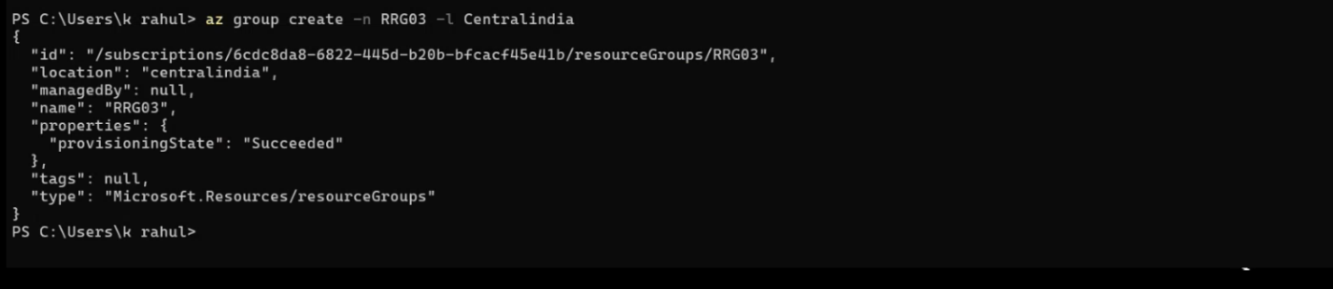
Resource of VM Using Azure Cli :
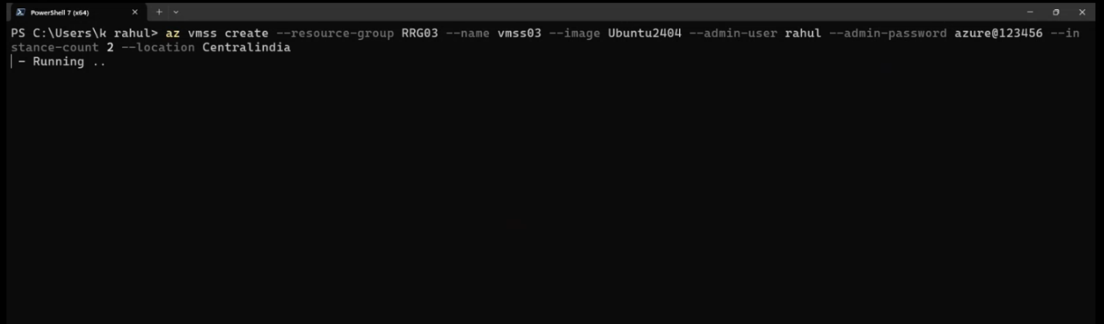
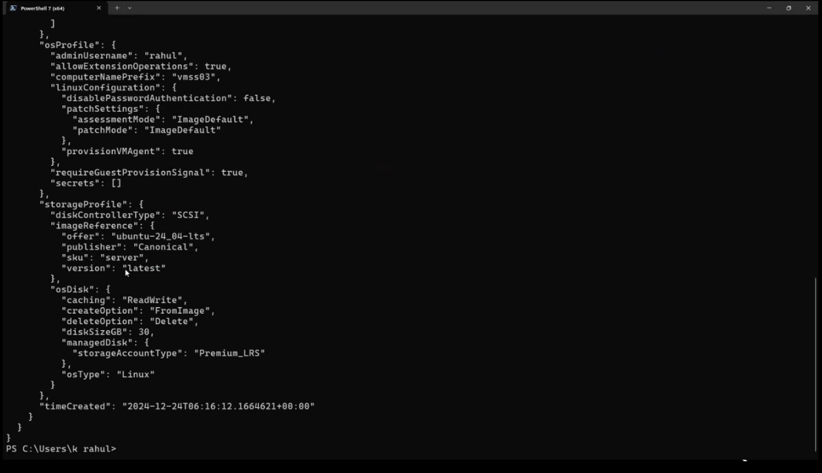

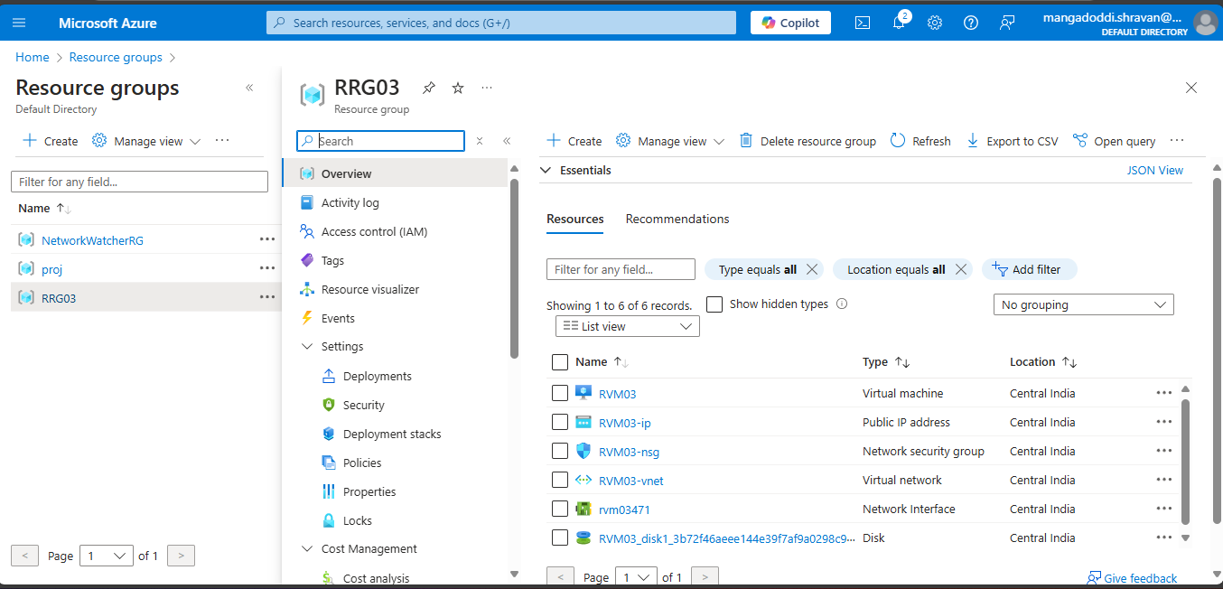

Updating the Ubuntu VMSS : ( sudo apt update )

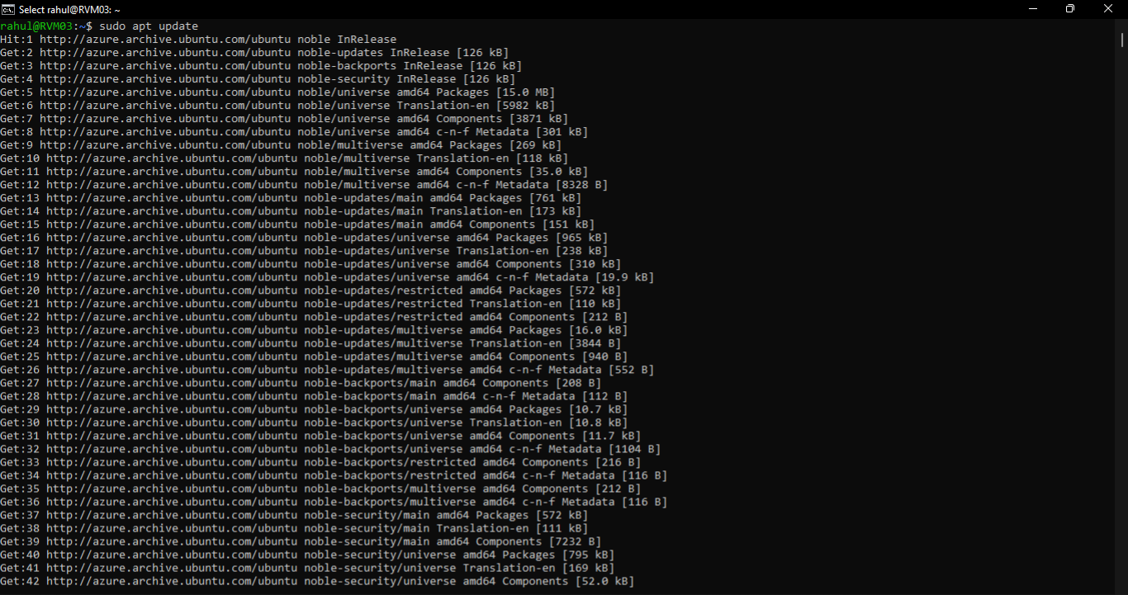
Installing nginx : ( sudo install nginx )

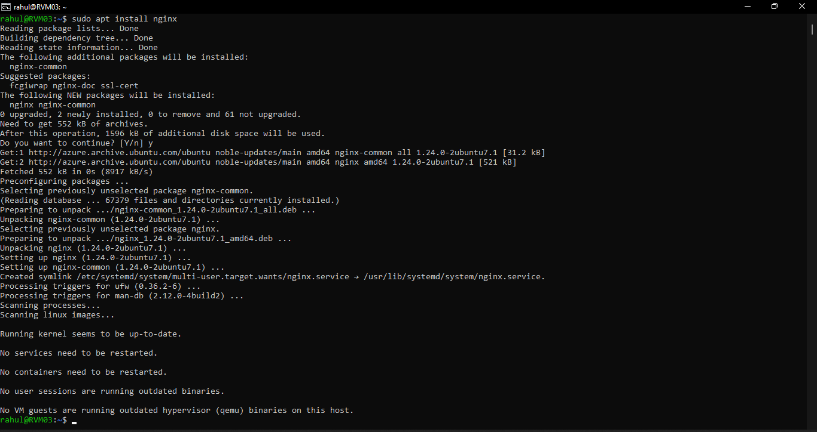

Entering in to nginx : ( / var/www.html )
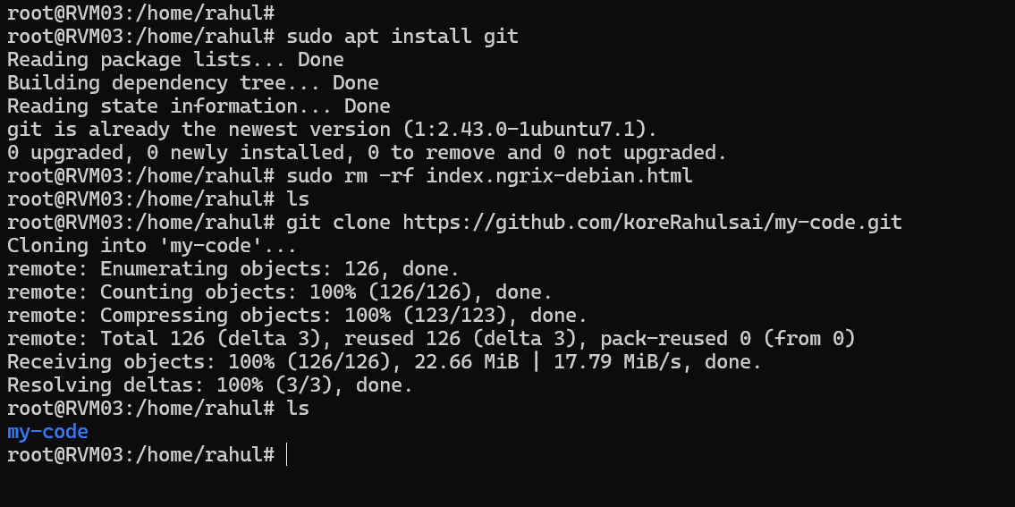

Installing Git: ( sudo apt install git )
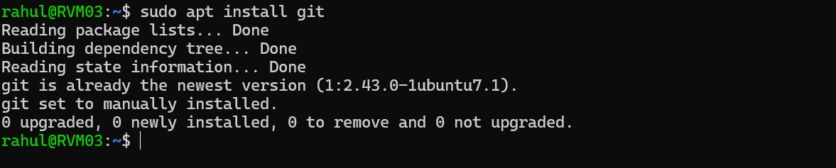

Coping of URL git :

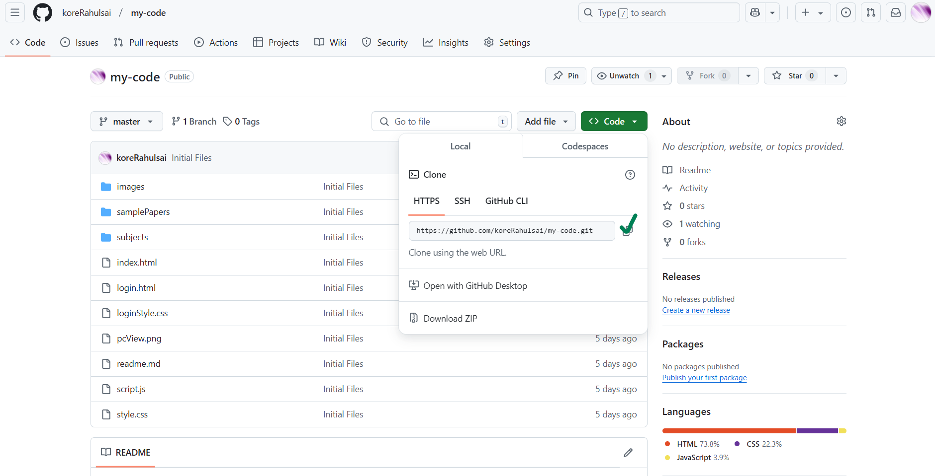

Clone the git hub repository : ( Git hub clone <link> )

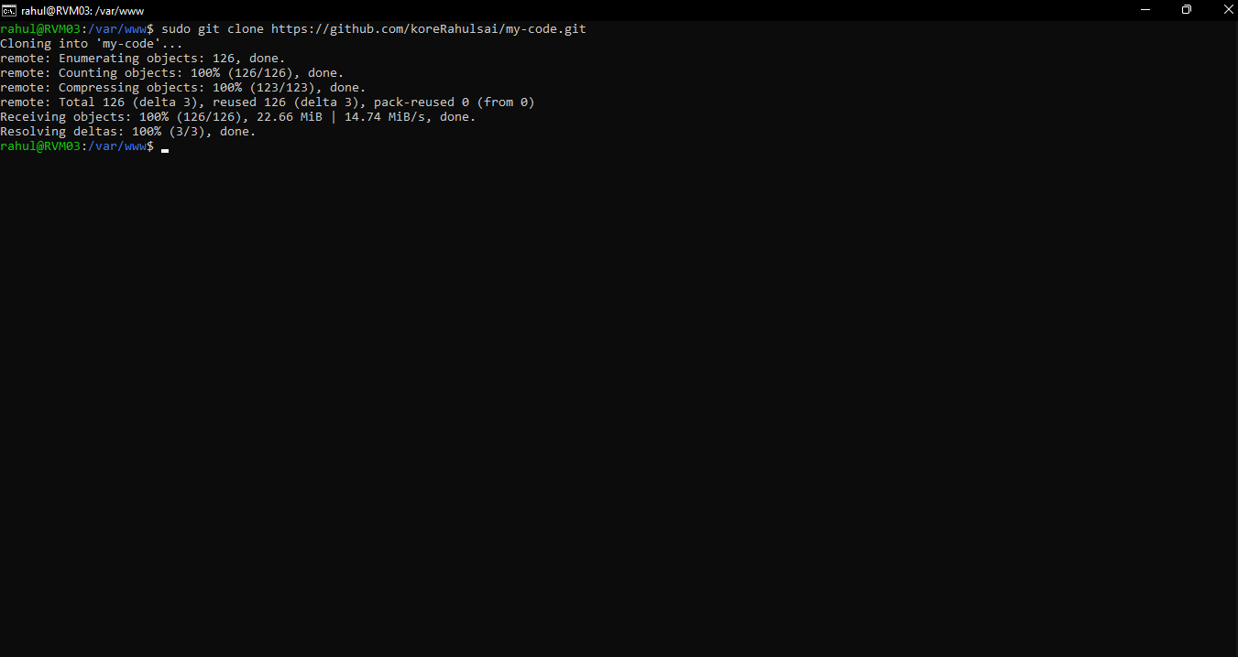

Web Homepage :

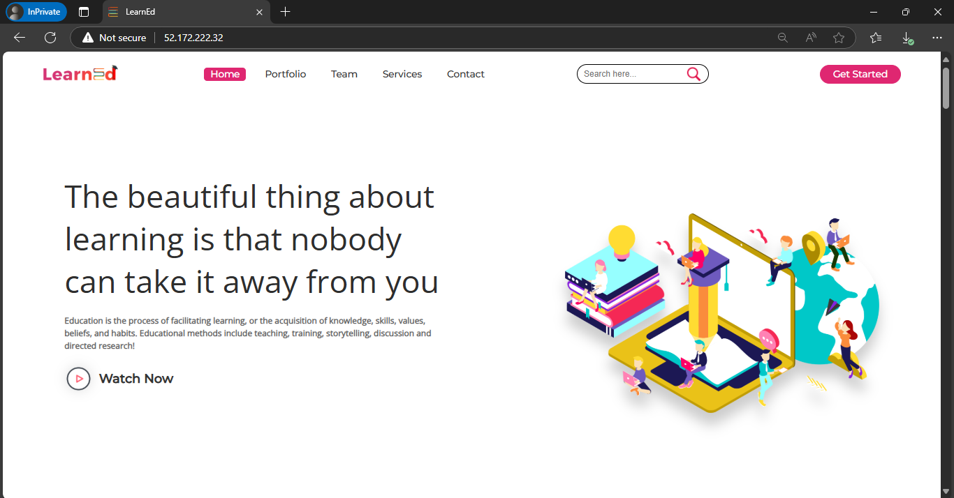

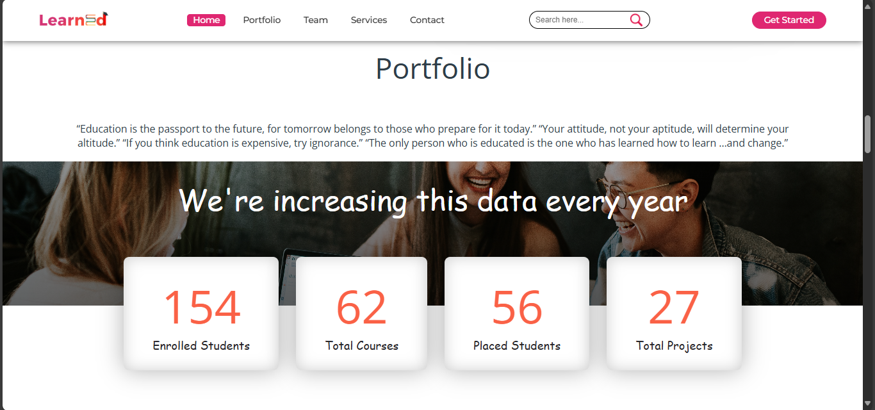

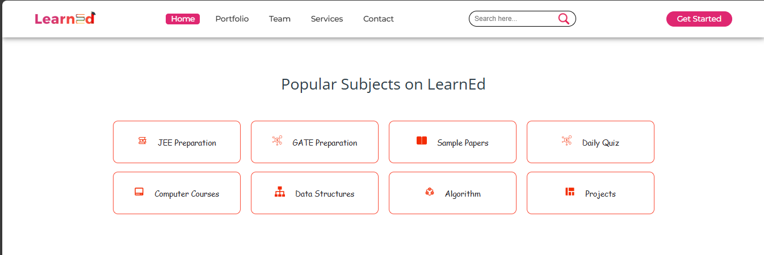

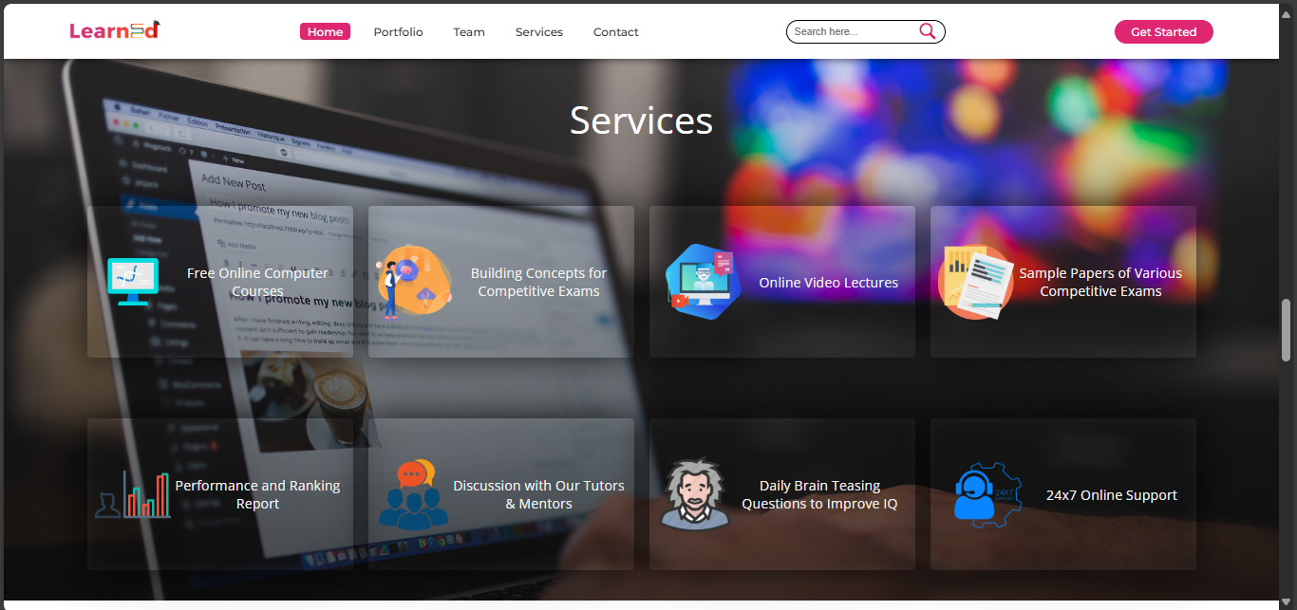
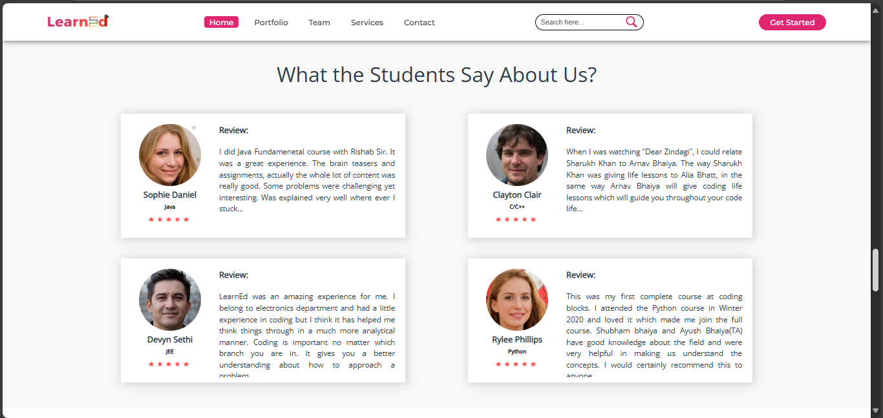

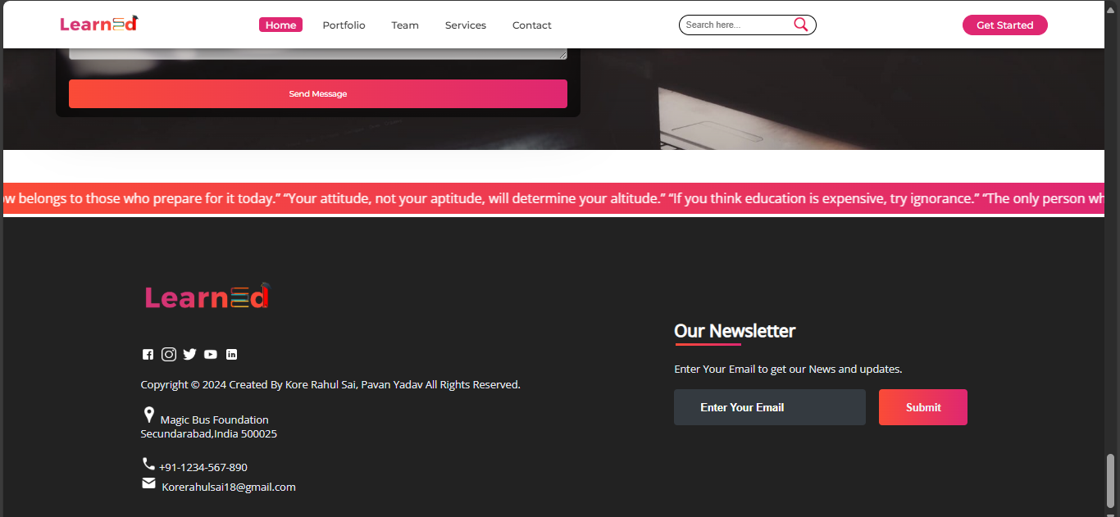

Conclusion :
Deploying a static website using Virtual Machine Scale Sets (VMSS) is a scalable, reliable, and cost-effective solution. VMSS ensures high availability through automatic scaling and load balancing, making it ideal for handling varying traffic demands. This approach simplifies infrastructure management, optimizes resource utilization, and provides flexibility for future growth. With VMSS, hosting a static website becomes efficient and resilient, allowing developers to focus on delivering an exceptional user experienceThis approach provides a robust infrastructure for static websites, empowering businesses to deliver consistent and reliable user experiences while maintaining operational efficiency. VMSS is not only a solution for today's needs but also a foundation for future growth and technological advancements. Deploying with VMSS demonstrates the power of leveraging cloud-native scalability to meet modern web hosting demands.

